Q1. Answer :

Given :.

|  |  |  |  |  |
| --- | --- | --- | --- | --- |
| I | 1 | 2 | 3 | 4 |
| W | 2 | 4 | 5 | 9 |
| P | 10 | 10 | 12 | 18 |
|  |  |  |  |  |

Tree calculation :

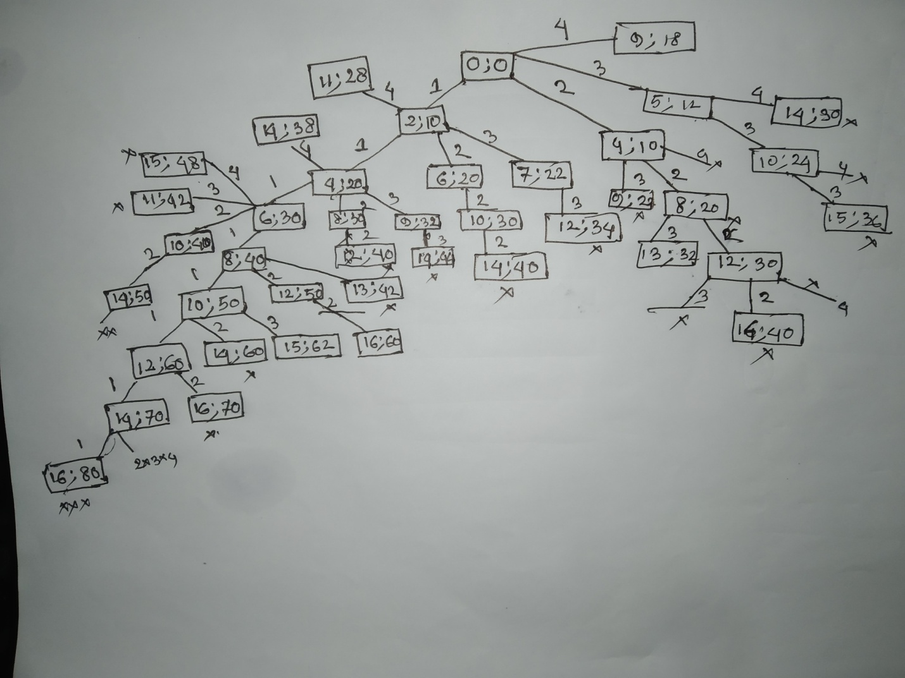

Here,If (capacity>current_weight)

We will take that weight and profit.

Otherwise not. And by this method we have to calculate maximum profit.

First we have to consider node 0,0

Considering node 1 :

If we take item 1 for 8 times, we get profit 8*10 = 80

We can see non other of node 1 can get 80.In the tree we get items,2,3,4 ,,but here for node 1,maximum profit is 80.

Considering node 2 :

If we take item 2,for 4 times, we get profit 4*10 = 40

We can see non other of node 1 can get 80.In the tree we get items 3,4 ,,but here for node 1,maximum profit is 40.

Considering node 3 :

Similarly, we can see maximum profit is 40 in tree .

Considering node 34:

Similarly we can see maximum profit is 18 in tree .

So , we can see If we take item 1 for 8 times = 2*8 = 16 capacity , Maximum profit 80 (Answer)